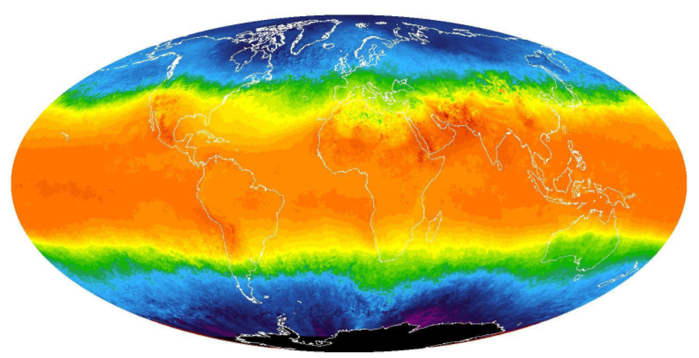

Explore weather trends

Project #01

September 25, 2018



Student: Mohamed Zeghlache

Biskra, Algeria

# **Overview:**

In this project, I will will analyze local and global temperature data and compare the temperature trends in “Algiers, Algeria” to overall global temperature trends.

I will create a visualization and prepare a write up describing the similarities and differences between global temperature trends and temperature trends in “Algiers, Algeria”.

## **Work plan :**

* **Extracting Data:** I will be using the data provided by Udacity to pull the appropriate information (using SQL) that will make me do the right analysis.
* **Exporting data to a spreadsheet:** I will be exporting data to a google spreadsheet in order to calculate the moving average and make a line chart of it.
* **Making observations:** I will be using the visualization that I made in the spreadsheet to make some observations and conclusions about the similarities about the world’s average temperature and “Algiers’” average temperature.

## **Analysis :**

1. **Data Extraction :**

* First , I enquired the « city_list » table , to pull all the cities from my country that are available on that table :

SELECT *

FROM city_list

WHERE country = ‘Algeria’

The result to this query was only one city which is “Algiers”.

* Then , I used the result of the last query to pull data from the « city_data » table :

SELECT year , avg_temp

FROM city_data

WHERE city = ‘Algiers’ AND country = ‘Algeria’

I added “where country = ‘Algeria’” just to eliminate any other city in the world called Algiers

* Finally, I pulled the data that concerns the global temperature from the « global_data » table :

SELECT *

FROM global_data

1. **Exporting data :**

* I used the last two SQL queries to export the data to a google sheet in order to calculate the moving average of both global temperature and Algiers’ temperature .

The command that was used to calculate the moving average of the global temperature for the first 10 years is:

=average(B2:B11)

And then, I just pull down plus sign to fill the rest of the cells automatically

And the same with calculating the moving average of Algiers’ temperature :

=average(F5:F14)

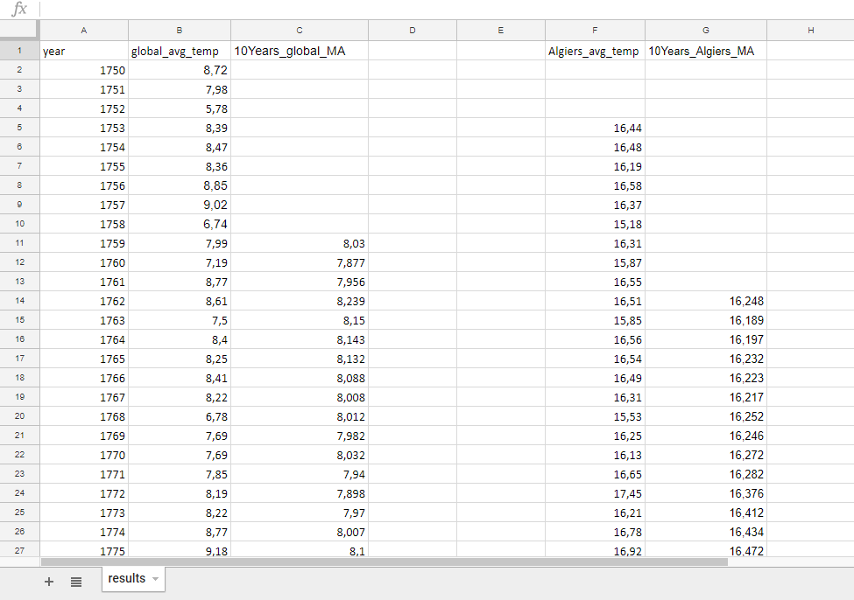

* After calculating the 10 years moving average , I made a line chart for the moving average of both average temperatures of the world and Algiers :

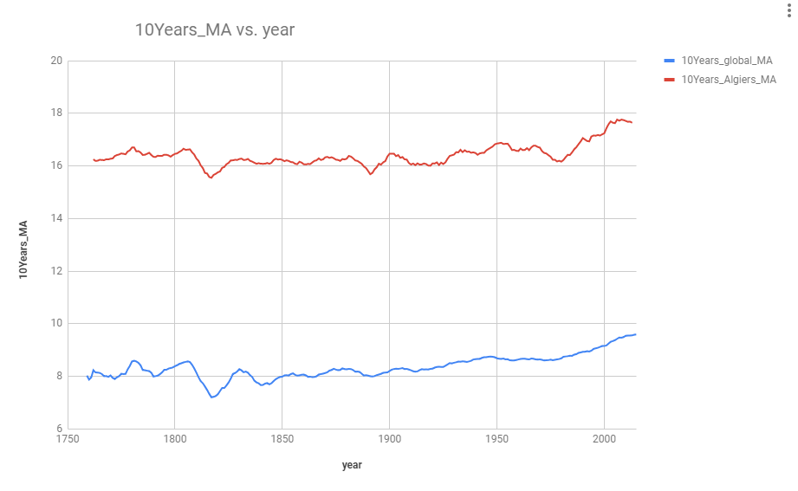

1. **Observations :**

* There is a clear difference between the average temperature of the world and Algiers, the average temperature of the world varies almost between 7°C and 9.5°C, however the average temperature of Algiers varies almost between 15.5°C and 18°C. Which makes Algiers hotter than the world average temperature.
* Looking at the line chart, we can see that the difference between the average temperature of the world and Algiers is very consistent.
* The changes of the average temperature of Algiers is also consistent to the changes of the global average temperature , as we can see on the line chart ; almost every time the global temperature decreases so does the average temperature of Algiers , and the other way around too .
* Looking at the line chart we can clearly see that the overall average temperature is consistently increasing, it went up by almost 5°C in the last 200 years.

## **CONCLUSION:**

The average overall temperature is increasing (getting hotter) consistently during the last 200 years.

## tools used in this PROJECT:

* **SQL**: I used Structured Query Language (SQL) to extract data from the database.
* **Google sheets**: I used google spreadsheets to calculate the moving average of the average temperature and to make a line chart visualization.
* **Word 2013**: I used word 2013 to write this project.